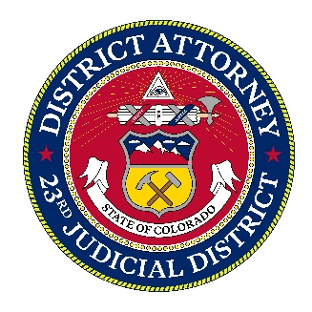

**MEDIA CONTACT:**

Tom Mustin

Media Relations Director

23rd Judicial District

Cell: 303-358-9375   
tmustin@coda23.gov

**For Immediate Release:**

**Castle Rock Woman Sentenced to Jail for Voter Fraud**

Joy Beth Lewis Submitted Ballot for

Deceased Landlord

**Castle Rock, CO** - On January 21, 2025, 70-year-old Joy Beth Lewis of Castle Rock was sentenced to twenty days in jail after pleading guilty to voter fraud. Lewis admitted to receiving a presidential ballot mailed to her deceased landlord, forging his signature, and submitting it. In addition, Lewis cast her own legitimate vote in the same election.

Douglas County Clerk and Recorder Sheri Davis says justice was served. :…” Senior Deputy DA Corrie Caler echoed those sentiments, saying, “Voter fraud erodes the core of our democracy, and it is vital that those who engage in such acts face consequences to preserve the integrity of our electoral system.

District Attorney George Brauchler emphasized the seriousness of the case, stating, “This sentence sends a strong message that voter fraud will not be tolerated in in Douglas County. We are committed to ensuring that voters can trust the election process, and anyone who undermines that will be held accountable.”

**####**