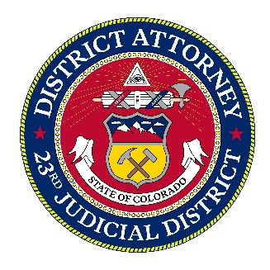
For Immediate Release:
January 14, 2025

MEDIA CONTACT:

Tom Mustin
Media Relations Director
23rd Judicial District
Cell: 303-358-9375
tmustin@coda23.gov

District Attorney and Douglas County Sheriff Sue Governor Polis Over U-Visa Statute

Castle Rock, CO –23rd Judicial District Attorney George Brauchler and Douglas County Sheriff Darren Weekly have filed a lawsuit against Governor Jared Polis challenging the constitutionality of a Colorado statute governing the certification of federally issued U-Visas. Also named as defendants are Attorney General Phil Weiser, Director of Public Safety Stan Hilkey, and Division of Criminal Justice Director, Matt Luan.

At issue is a state law addressing U-Visas, a tool for local law enforcement officers and prosecutors to seek temporary legal status from federal immigration officials for non-citizen crime victims and witnesses who are willing to assist law enforcement in the investigation and prosecution of those crimes.

Congress makes available only 10,000 U-Visas each year. Federal law provides significant discretion in law enforcement and prosecutors to determine when and whether to certify applications for U-Visas.

In 2021 the Colorado General Assembly attempted to take away that discretion when it adopted House Bill 21-1060. The lawsuit asserts the bill unlawfully interferes with federal immigration law by restricting the discretion of state officials and preventing them from considering all factors required under federal law, including whether the applicant has meaningful information related to the crime that is prosecutable in our courts.

“This misguided law attempts to force Colorado officials to rubber-stamp U-Visa applications, instead of exercising independent judgement as to which cases warrant the use of these powerful and scarce tools,” said District Attorney Brauchler. “The legislature has again injected politics into immigration law by converting this valuable tool for law enforcement into a “golden ticket” to stay in America, even if the non-citizen can do nothing to hold a bad guy accountable or improve public safety.”

Brauchler further noted that the statute limits what officials are permitted to communicate to federal authorities. “This bill strips public officials of the ability to make free and honest determinations and prevents them from communicating their honest opinions to the federal government. Those requirements are enforced through the threat of lawsuits brought by the Attorney General, leaving officials with no real choice but compliance.”

Douglas County Sheriff Darren Weekly warned that the law carries serious public safety consequences.

“This statute sets a dangerous precedent by forcing law enforcement to certify immigration applications even when the facts don’t support it,” said Weekly. “When politicians dictate outcomes and silence honest assessments it erodes truth in the justice system and compromises public safety. Decisions about cooperation and credibility should be made by law enforcement professionals – not mandated by statute.”

The lawsuit seeks to prevent enforcement of the law and to restore the lawful role of state and local officials in the federal U-visa process.

####

